INTERNSHIP / UDP / TRAINING REPORT – REPORTING 2
(Project Design and Implementation Progress Report)
1. Student Information
Student Name | DHRUVI MALANKIYA
Enrollment Number | 23SE02CE056
Program/Branch | B.TECH / COMPUTER ENGINEERING
Semester | 7th
Contact Number | 9313779161
Email ID | 23se02ce056@ppsu.ac.in

2. Internship / UDP / Training Details
Type | INTERNSHIP
Company/Organization | DURVASA INFOTECH
Department/Domain | PYTHON DATA SCIENCE
Mentor Name (Company) | DARSHAN CHAUHAN
Mentor Name (Institute) | Dr. JAYSHRI PATIL
Start Date | 01/06/2026
End Date | 15/10/2026

3. Work Progress Summary
- Project Title:
Smart Healthcare Analytics System

b) Brief Overview of Work Completed After Reporting 1
After Reporting 1, significant progress has been made in the development of the PulseAI – Smart Healthcare Analytics System. The frontend of the web application has been designed and implemented using React.js and Tailwind CSS, focusing on a modern, responsive, and user-friendly interface.
The completed work includes the landing page, authentication pages (Sign In, Sign Up, Forgot Password), and a comprehensive healthcare dashboard. Multiple frontend modules such as Health Analytics, Health Records, Risk Assessment, AI Recommendations, Daily Planner, Progress Tracking, Reports, Achievements, Streaks, Profile, and Settings have been developed with proper navigation and UI components.
Currently, the application contains interactive dashboards, charts, health score cards, and various healthcare management interfaces using frontend technologies. The backend development using Node.js, Express.js, and MongoDB is the next phase, where real patient data, authentication, AI prediction logic, database integration, and API development will be implemented to replace the temporary frontend data.
At this stage, the project is successfully prepared for backend integration and further AI-based healthcare analytics implementation.
c) System Architecture / Workflow Diagram :

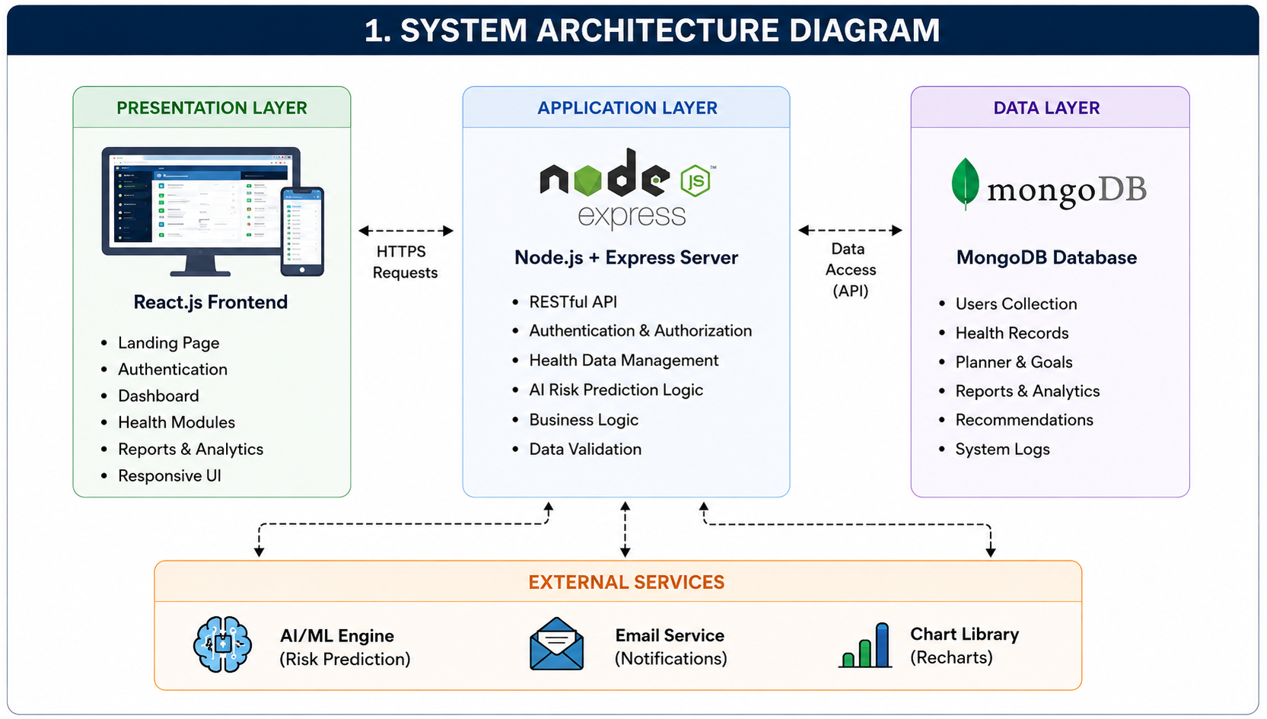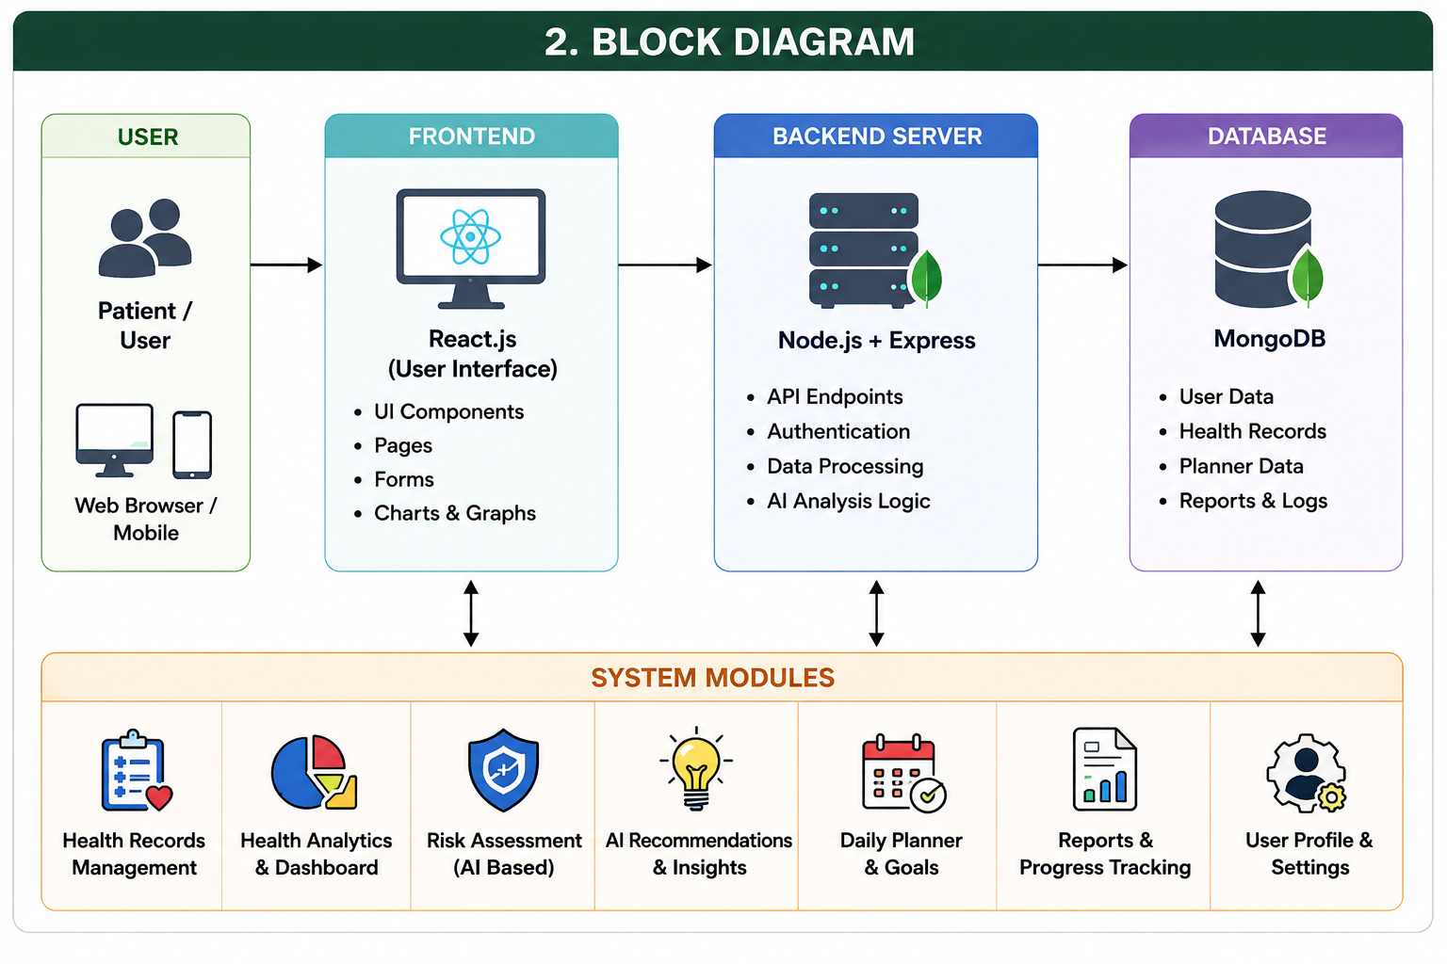
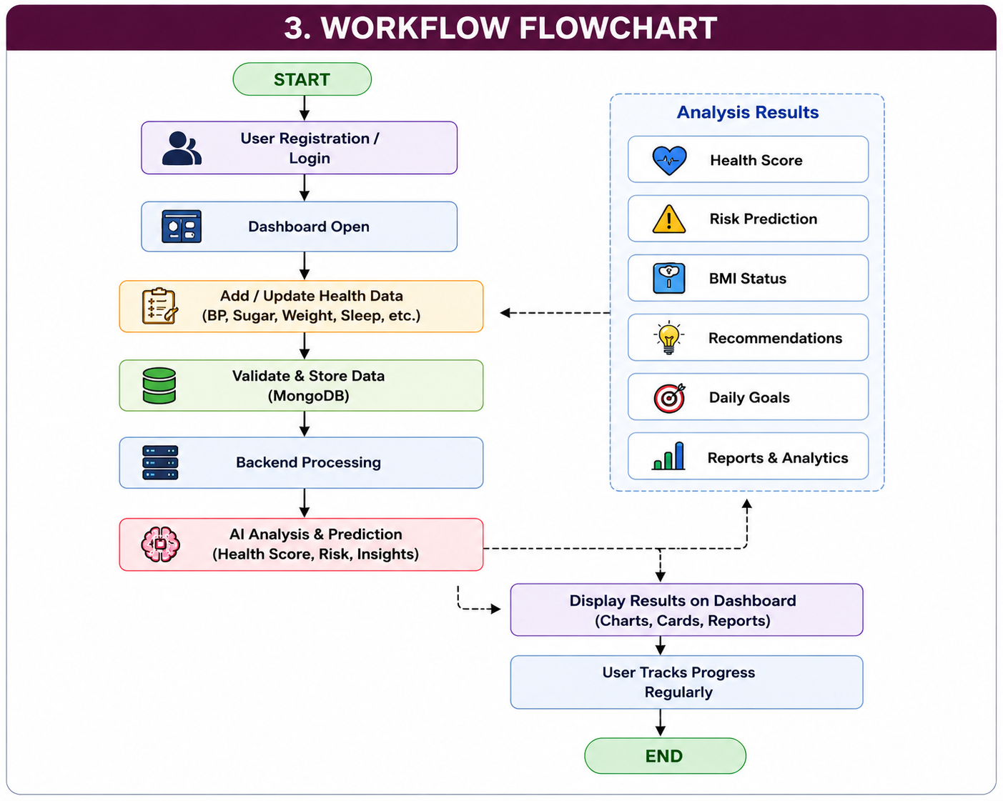
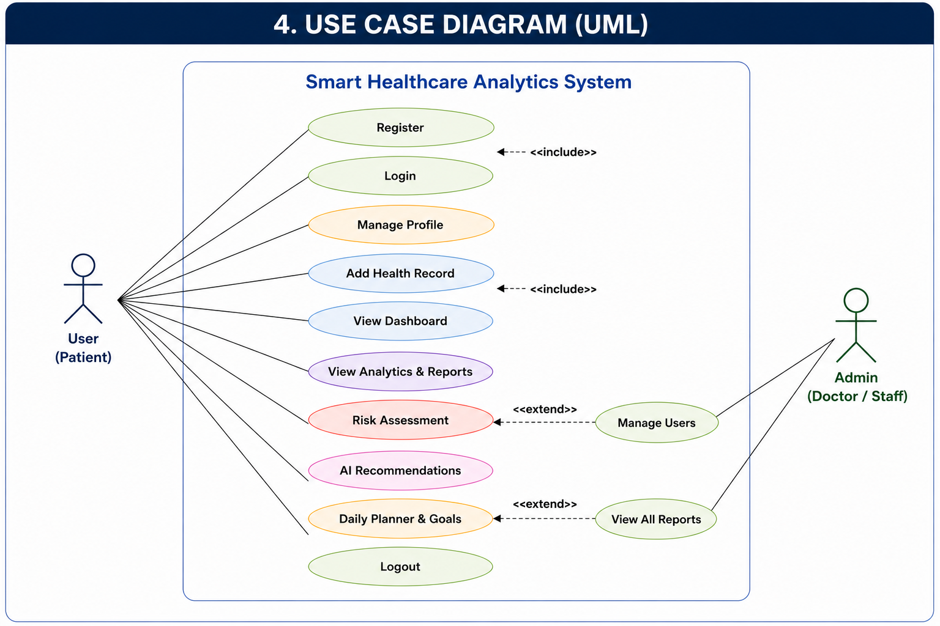

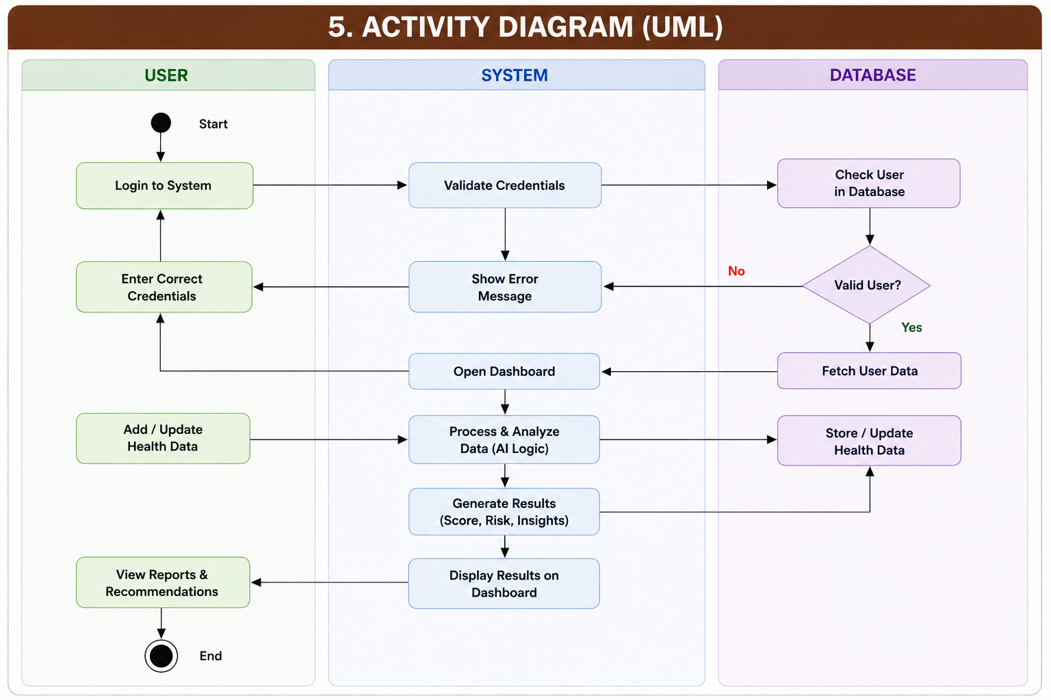

d) Modules Completed / Features Implemented
Module Name | Description | Current Status
Landing Page | Developed a responsive landing page with Hero section, Features, Testimonials, FAQ and Contact section. | Completed
User Authentication | Designed Sign In, Sign Up, Forgot Password and Reset Password interfaces. | Completed
Dashboard | Developed an interactive healthcare dashboard with health metrics and analytics cards. | Completed
Health Records | Created UI for adding, viewing and managing patient health records. | Completed
Health Analytics | Implemented analytics interface with charts and health score visualization. | Completed
Risk Assessment | Designed disease risk prediction and health assessment interface. | Completed
Recommendations | Developed personalized health recommendation interface. | Completed
Daily Planner | Created daily planner and task tracking module. | Completed
Progress Tracking | Implemented health progress tracking and performance monitoring UI. | Completed
Reports | Developed weekly and monthly report interface. | Completed
Achievements & Streaks | Created achievement badges and streak tracking interface. | Completed
Profile & Settings | Developed user profile management and settings pages. | Completed
Backend Development | Developing REST APIs, authentication and server-side logic using Node.js and Express.js. | In Progress
MongoDB Integration | Database schema creation and MongoDB connectivity. | In Progress
Frontend-Backend Integration | Connecting frontend with backend APIs and database. | In Progress

e) Tools and Technologies Used
Programming Language: JavaScript, HTML5, CSS3
Framework: React.js, Node.js, Express.js
Database: MongoDB (Integration In Progress)
Hardware/Software Tools: Visual Studio Code, Node.js, npm, Git, GitHub, MongoDB Compass, Postman, Google Chrome, Windows 11
Other Technologies: Tailwind CSS, React Router DOM, Axios, JWT Authentication, REST API, Lucide React Icons, Chart.js/Recharts (for analytics), Vite

4. Implementation Description
explain:
- Algorithm / Method followed : The Smart Healthcare Analytics System follows a user-centric workflow. Initially, the user registers and logs into the system. After authentication, the user can access the healthcare dashboard. The dashboard is designed to collect and display health-related information such as BMI, blood pressure, blood sugar, water intake, exercise duration, sleep data, and daily activities. Based on the health data entered by the user, the system is planned to perform risk assessment and generate personalized health recommendations. Currently, the frontend workflow has been completed, while backend processing and database integration are under development.
- Coding / Development details : The frontend of the project has been developed using React.js with reusable and modular components. React Router DOM is used for page navigation, while Tailwind CSS is used for responsive and modern user interface design. The application includes Landing Page, Authentication Module, Dashboard, Health Records, Analytics, Risk Assessment, Recommendations, Daily Planner, Reports, Achievements, Profile, and Settings pages. Node.js and Express.js are selected for backend development, which is currently in progress.
- Database design : MongoDB has been selected as the database for storing user information, authentication details, health records, daily activity logs, health reports, recommendations, and progress history. The database will contain separate collections for Users, Health Records, Daily Planner, Reports, Achievements, and Risk Assessment. Database schema design has been planned, and implementation is currently in progress.
- API integration : REST APIs are planned to connect the React frontend with the Node.js and Express.js backend. APIs will handle user authentication, health record management, analytics generation, report retrieval, and recommendation services. At present, frontend interfaces have been completed, while API development and integration are under progress.
- Testing performed : Frontend testing has been performed by executing the application on the local development server. Navigation between pages, responsive layouts, dashboard rendering, authentication interface, and UI components were verified successfully. Backend API testing and MongoDB integration testing will be performed after completion of the server-side development.

5. Results / Output Screenshots
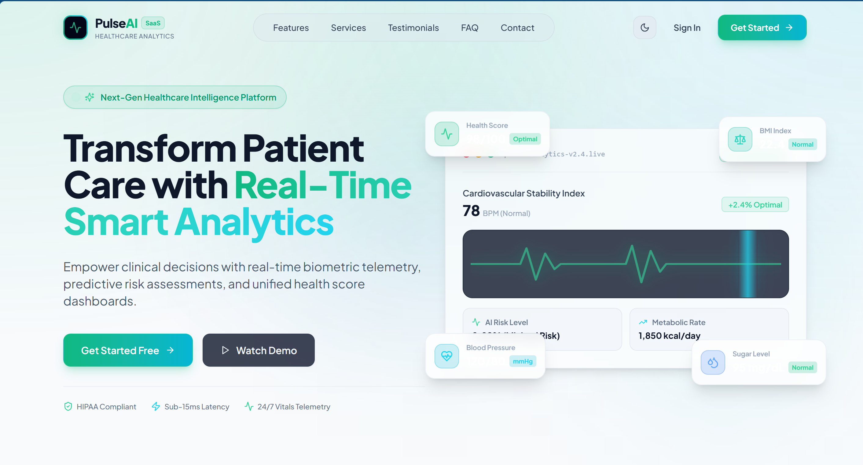
The Home Page serves as the landing page of the Smart Healthcare Analytics System. It introduces the platform with a modern and responsive user interface, highlighting its key features such as real-time health analytics, AI-based risk assessment, health score monitoring, and personalized recommendations. The page includes navigation menus, call-to-action buttons (Get Started and Sign In), feature sections, testimonials, FAQ, and contact information to provide users with a complete overview of the application.

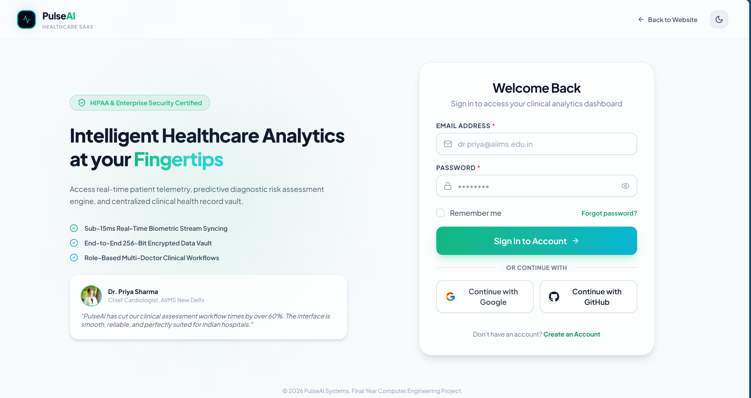
The Login Page provides a secure authentication interface for registered users to access the Smart Healthcare Analytics System. It includes email and password fields, "Remember Me" functionality, password recovery option, and social login support. The page is designed with a modern, responsive user interface to ensure secure and user-friendly access to the healthcare dashboard.
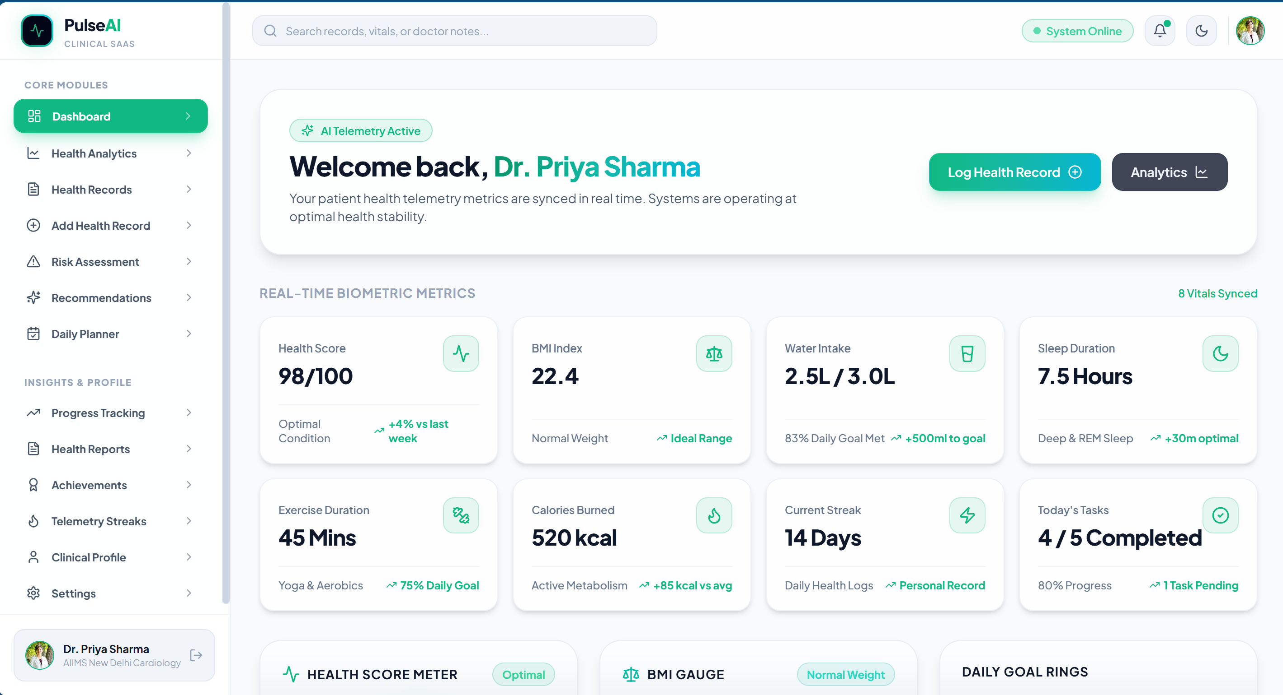
The Dashboard serves as the central interface of the Smart Healthcare Analytics System. It provides a comprehensive overview of the user's health information, including Health Score, BMI, Water Intake, Sleep Duration, Exercise Progress, Calories Burned, Daily Tasks, and Activity Streak. The dashboard also offers quick navigation to modules such as Health Analytics, Health Records, Risk Assessment, Recommendations, Reports, and Profile, enabling users to monitor their health status and manage healthcare activities efficiently from a single platform.
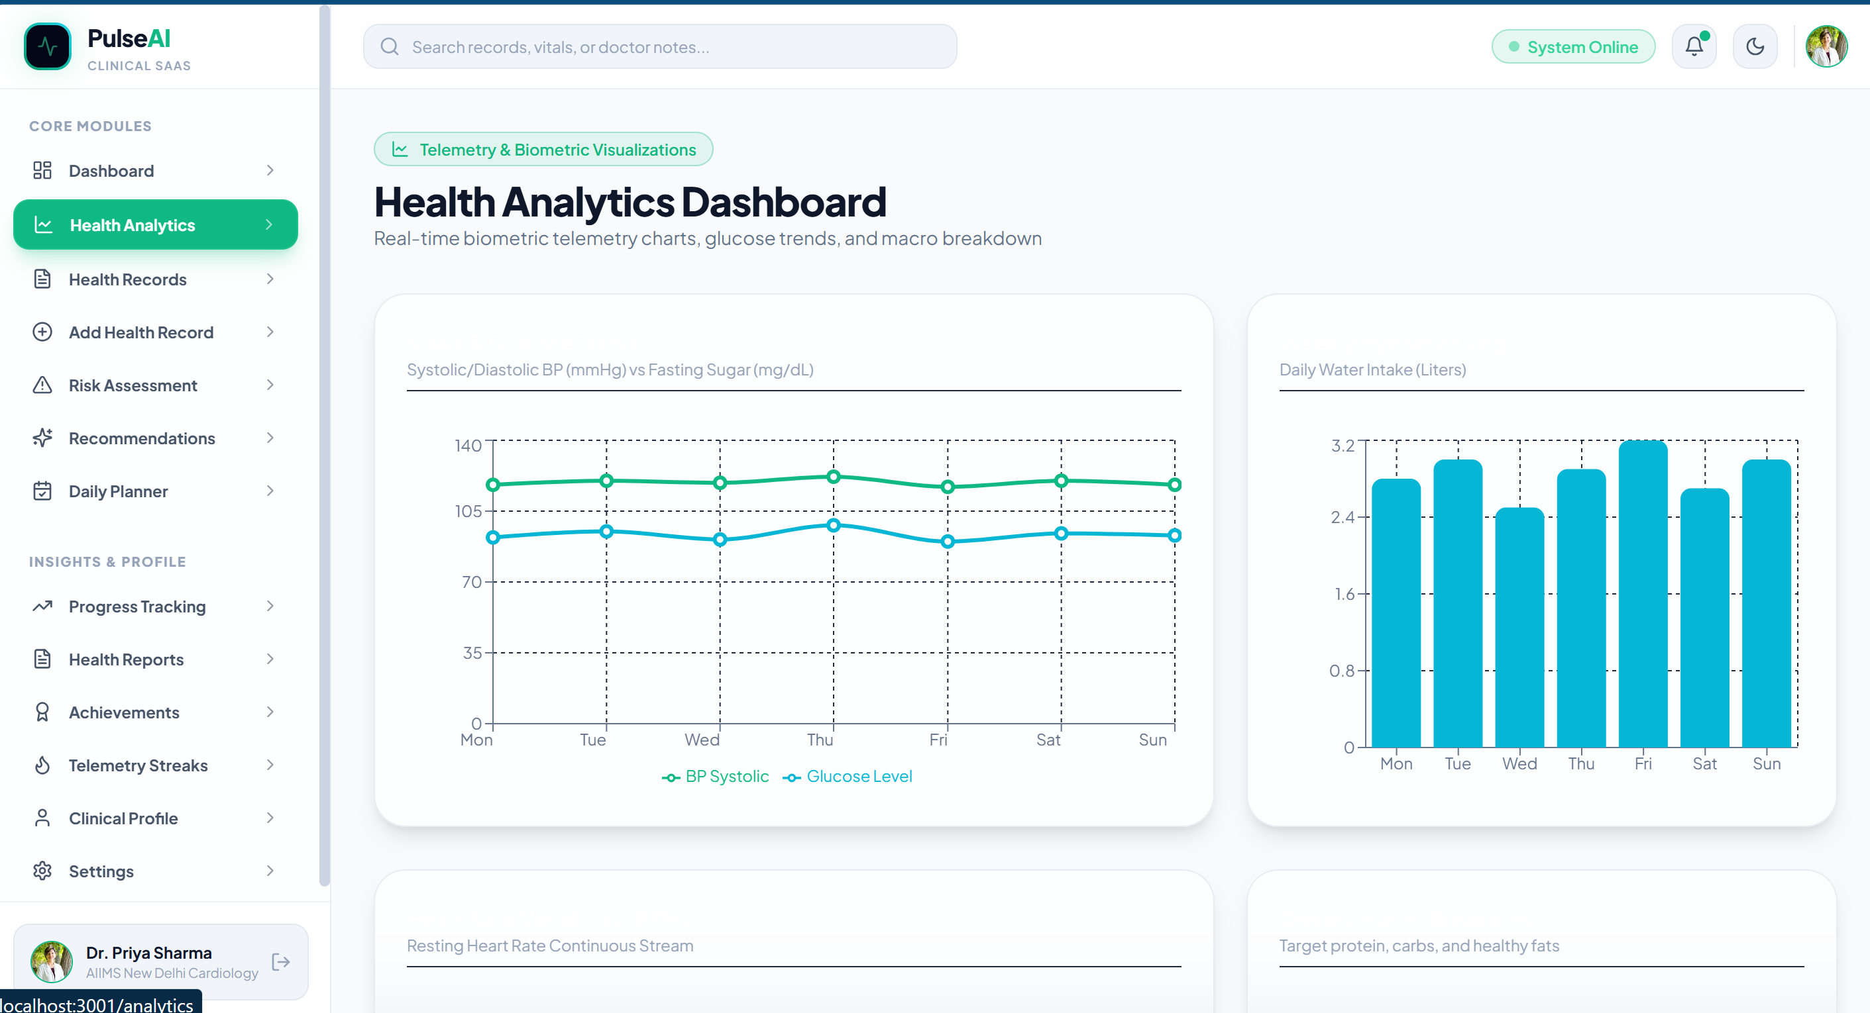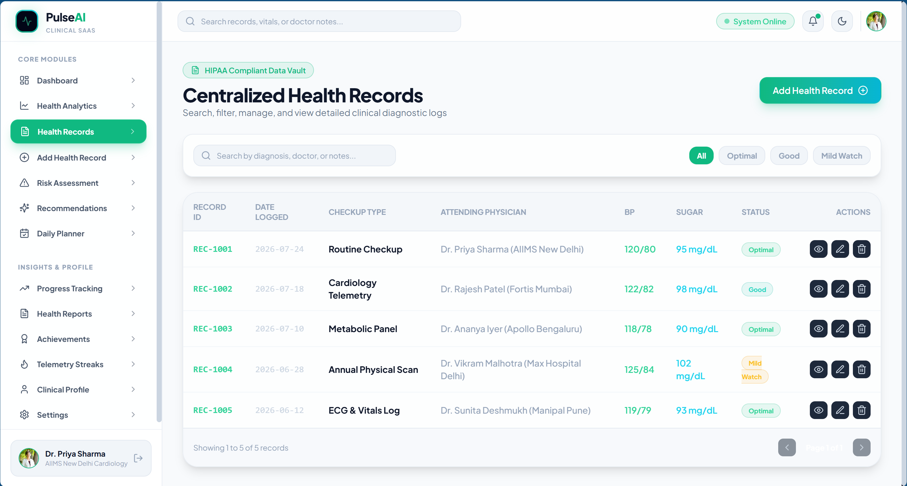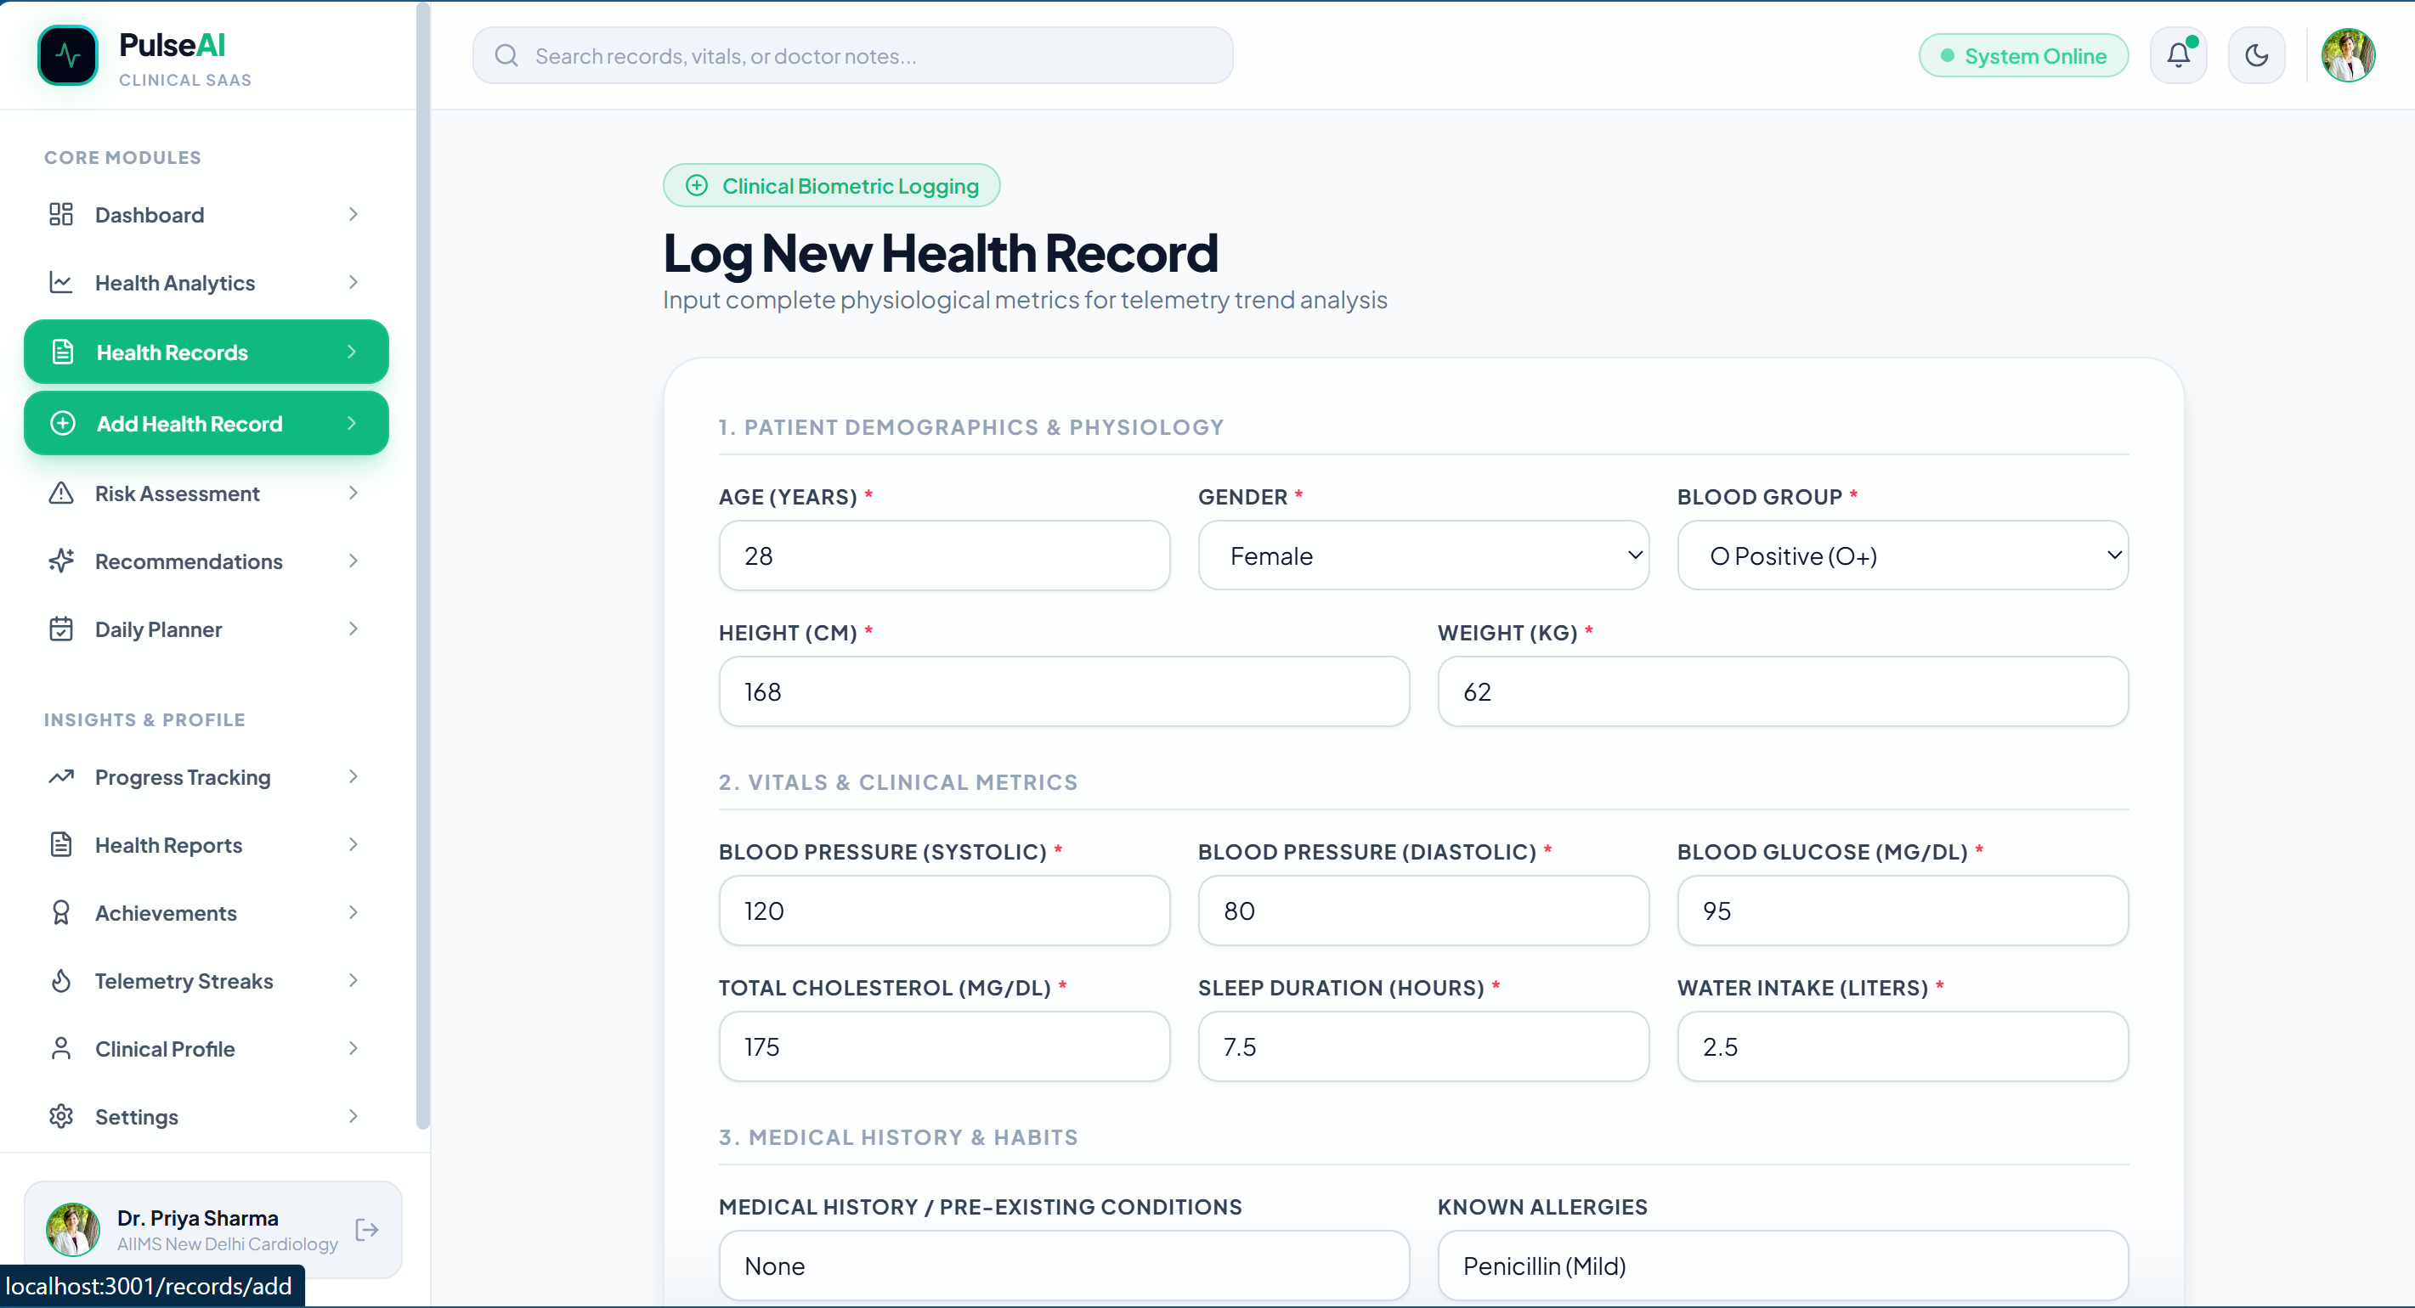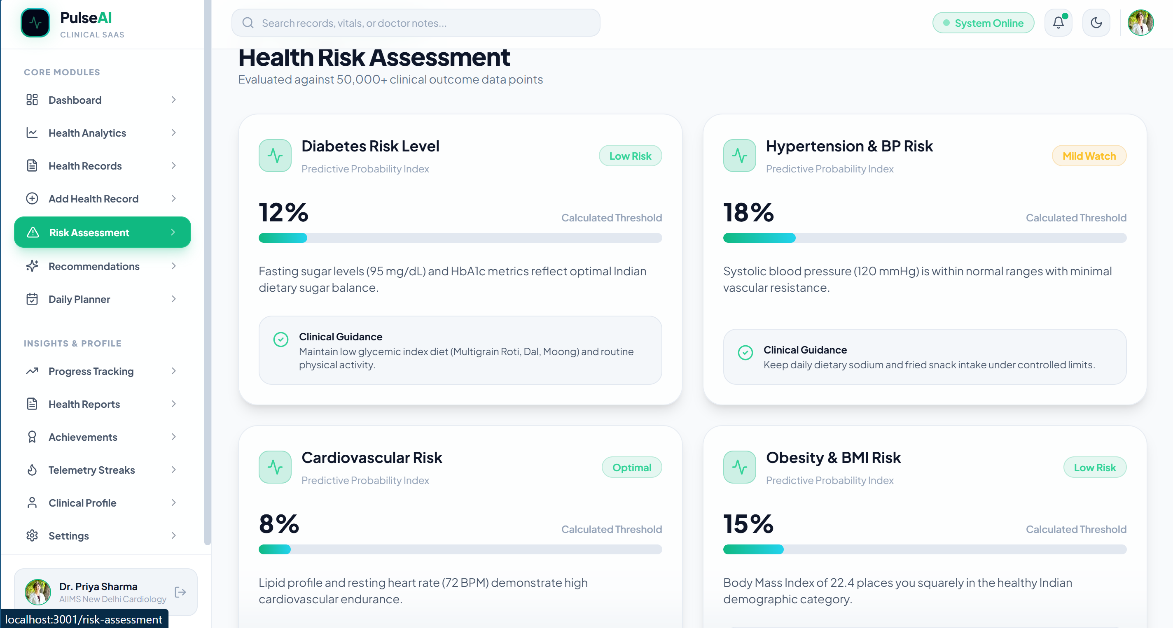
Note: The information displayed in the dashboard is currently dummy/sample data used only for frontend design, user interface demonstration, and workflow visualization. Real-time health data, AI-based predictions, database connectivity, and backend functionality will be integrated in the next development phase using the MongoDB database and backend APIs.

6. Challenges Faced and Solutions

Challenge Faced | Solution Applied
Designing a professional and responsive healthcare user interface. | Used React.js, Tailwind CSS, reusable components, and responsive layouts to build a modern UI.
Managing multiple pages and navigation within the application. | Implemented React Router for smooth routing and organized the project into modular components.
Creating a consistent dark theme across the application. | Used a common color palette, reusable UI components, and global styling for consistency.
Building healthcare dashboard without real-time backend data. | Used temporary dummy/sample data to develop and test the frontend interface.
Organizing the project into multiple modules and maintaining code structure. | Followed a component-based architecture and separated modules into different folders for better maintainability.
Integrating authentication before backend development. | Implemented frontend authentication flow and planned backend API integration for the next phase.

Note: Since the project is currently in the frontend development phase, challenges related to backend API integration, MongoDB connectivity, AI prediction model integration, and deployment will be addressed in the next development stage.

7. Tasks in Progress / Next Month Plan
- Remaining modules :
- Backend development using Node.js and Express.js.
- MongoDB database integration.
- User authentication using JWT.
- Health record CRUD operations.
- AI risk prediction module integration.
- Dashboard with real-time data fetching.
- Report generation and export functionality.

- Testing plan :
- Unit testing of backend APIs.
- Frontend and backend integration testing.
- Database connectivity testing.
- Authentication and authorization testing.
- End-to-end system testing.
- Bug fixing and performance optimization.

- Documentation work :
- Update project documentation.
- Prepare API documentation.
- Update database schema documentation.
- Add system architecture and workflow diagrams.
- Prepare final project report with screenshots and results.

- Deployment plan :
- Deploy frontend application.
- Deploy backend server.
- Configure MongoDB database.
- Perform final testing on deployed application.
- Verify complete system functionality before final submission.
8. Learning / Skills Acquired

- Technical Skills Learned:
- React.js based frontend development.
- Component-based UI design and reusable components.
- Responsive web design using Tailwind CSS.
- Client-side routing using React Router DOM.
- Dashboard design with charts and analytics visualization.
- Form validation and user authentication UI development.
- Project structure and code organization.
- Basic understanding of Node.js, Express.js, and MongoDB for full-stack development.
- Version control using Git and GitHub.

- Professional Skills Learned:
- Project planning and requirement analysis.
- Problem-solving and logical thinking.
- UI/UX design principles for healthcare applications.
- Time management and task prioritization.
- Debugging and troubleshooting frontend issues.
- Documentation and technical report preparation.
- Team communication and collaboration.
- Self-learning through official documentation and practical implementation.

9. References
References / Resources Used
Website References
[1] React Documentation, React Official Documentation, https://react.dev/, Accessed July 2026.
[2] Node.js Documentation, Node.js Official Documentation, https://nodejs.org/docs/latest/api/, Accessed July 2026.
[3] Express.js Documentation, Express.js Official Documentation, https://expressjs.com/, Accessed July 2026.
[4] MongoDB Documentation, MongoDB Official Documentation, https://www.mongodb.com/docs/, Accessed July 2026.
[5] Tailwind CSS Documentation, Tailwind CSS Official Documentation, https://tailwindcss.com/docs, Accessed July 2026.

Evaluation (To be filled by Mentor (Institute))
Criteria | Bloom’s Level | Excellent (20) | Good (15) | Average (10) | Poor (5) | Marks Obtained (Out of 20)
Work Completion | L3–Apply | ≥50% work completed with proof | 30–50% | <30% | No progress
Methodology Implementation | L3–Apply / L4–Analyze | Method clearly applied and justified | Partial implementation | Unclear | None
Tools & Technologies | L3–Apply | Tools used effectively with justification | Tools used | Limited use | No tools
Documentation | L2–Understand / L3–Apply | Proper logs, evidence | Partial proof | Minimal | None
Understanding of Work | L2–Understand / L4–Analyze | Strong conceptual clarity | Moderate | Basic | No understanding
Total Marks

Evaluation
Student Signature | Mentor (Company)  Signature | Mentor (Institute)  Signature

Mentor (Institute) Remarks
________________________________________________________________________________________________________________________________________________________________________________________________________________________________________________________________________________________________________________________________________________________________________________________________________________________________________________________________________________________________________________________________________________________________________________________________________________________________________________________________________________________________________________________________________________________________________________________________________________________________________________________________________________________________________________________________________________________________________________________________________________________________________________________________________________________________________________________________________________________________________________________________________________________________________________________________________________________________________________________________________________________________________

